Life on Earth

Earth Science Study Guide Study GUide

Population Size

Study Tip

Population Size

The prefix a- means “not” or “opposite”, and the root “bio” means alive. Thus, biotic factors are living factors, and abiotic factors are not.

* Biotic and abiotic factors determine the population size.
  + Biotic factors include the amount of food avalible and the number of organisms that use this food.
  + Abiotic factors are temperature, space, water, and sunlight.
* For a population to grow, there must be enough resources and no major problems.
* A population may shrink if the biotic and the abiotic factors change.

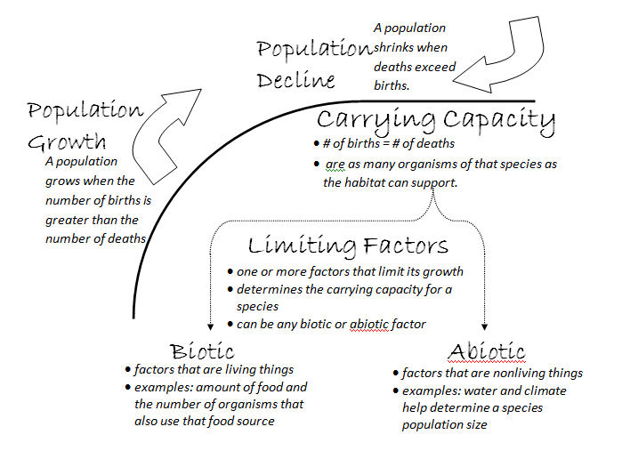Carrying Capacity

* The carrying capacity is when the number of births equals the number of deaths.
  + The carrying capacity is the greatest number of organisms of that species that the habitat can support.
  + The carrying capacity depends on biotic and abiotic factors of the habitat.

The size of a population is dependent on many different factors.

Limiting Factors

* Limiting Factors are the parameters that limit the growth of the population.
* The limiting factors determine the carrying capacity of a species.
* There are abiotic and biotic factors to how large of a population an environment can support.
* A **limiting factor** could be any abiotic or biotic factor.

Concept Check

* What is an example of an abiotic factor? A biotic factor?
* What does the carrying capacity mean?